Localization Process Overview for the Child Car Safety Campaign

The National Highway Traffic Safety Administration (NHTSA) and the Ad Council have produced public service advertising (PSA) materials for the Child Car Safety campaign. Previously, we worked together on two child occupant safety campaigns – Child Passenger Safety, targeted to parents with young children (children under 13 years old), and Seat Belt Safety, targeted to parents of tweens (children ages 8-14). In 2018, the Ad Council and NHTSA combined the two efforts under one campaign and strategic approach: Child Car Safety.

The campaign is designed to educate parents and caregivers about the importance of properly securing their age 1-14 children in the best car seat restraint (rear-facing car seat, forward facing car seat, booster seat, or seat belt) for their age and size as well as reminding them to buckle up their child in the back seat. The materials available for localization include television, print, and outdoor ads.

The national PSAs direct audiences to visit NHTSA.gov/TheRightSeat, or NHTSA.gov/Protegidos for Spanish speaking audiences, to receive the latest information on keeping their child safe and using the right car seat for their age and size.

The National Highway Traffic Safety Administration (NHTSA), and the Ad Council have intentionally designed these ads in a format that is easy to localize. This means state and local partners can “tag” the PSAs with their logo, URL, and/or phone number (if applicable in TV, print, and outdoor only) in order to direct parents to their own local website (if available) or for branding the national PSAs with their logo to drive to NHTSA.gov/TheRightSeat.

Steps to Localizing

- Determine which media (TV, outdoor, print), lengths, and sizes you are interested in localizing.

- Read this document and complete the associated order form and submit it via email to Elizabeth.Nilsson@dot.gov. Include EPS file of your logo for TV/Print/Outdoor localizations. In addition, please share any required delivery specs you or your vendor may have.

- NHTSA and Ad Council will review each request and will provide response within 2 weeks.

- Once approved, allow 4-6 weeks for Ad Council production.

- Ad Council and NHTSA to send final directly via email.

Limitations of Localizing

The following outlines limitations when localizing:

- Only use the PSA during the approved usage periods provided by the Ad Council, which can be found in the below associated columns as well as in the Expiration Date Form(s) fields on the Child Car Safety page of Ad Council’s fulfillment website. Please reference expiration date forms to ensure correct usage.

- Be mindful of talent usage rights and ability to run the PSA in either donated media space and time (meaning that the space or time was not paid for) or paid space and time. Some ads cannot run in paid media as this is a violation of Screen Actors Guild and American Federation of Television and Radio Artists regulations.

- When tagged with local sponsor information (state agency, non-profit, etc.), the PSAs cannot include any references to commercial advertisers or their logos (for-profit, corporation, etc.).

- If using a local URL, no commercial elements can be present on the website’s home page.

- Also, please do not alter or use the body of any PSA for any other purpose or provide it to any third parties. Doing so will violate our contracts with the performers and contributors.

For radio, we are unable to customize voiceover at this time. If you’re interested in radio inventory, you are able to support national versions without changes. If you’d like to preview or download national assets, please visit our Find Assets page. As an alternative, we can also offer localizable live announcer copy that can be read by on-air talent. Copy for each available length is below:

  - :15: There’s nothing you wouldn’t do for your child – from watching their soccer game in the pouring rain to soothing a crying baby at 4am. And you do it all because you love them. Keep them safe by visiting NHTSA.gov/TheRightSeat to make sure they’re in the right seat for their age and size. Brought to you by the National Highway Traffic Safety Administration, [YOUR ORG HERE], and the Ad Council.
  - :30: There’s nothing you wouldn’t do for your child – from watching their soccer game in the pouring rain to soothing a crying baby at 4am. And you do it all because you love them. Keep them safe by visiting NHTSA.gov/TheRightSeat to make sure they’re in the right seat for their age and size. Car crashes are a leading cause of death for children under 13, but when used correctly, safety restraints can dramatically reduce the risk of fatality or injury, so visit NHTSA.gov/TheRightSeat today. Brought to you by the National Highway Traffic Safety Administration, [YOUR ORG HERE], and the Ad Council.
  - :60: There’s nothing you wouldn’t do for your child – from watching their soccer game in the pouring rain to soothing a crying baby at 4am. And you do it all because you love them. Keep them safe by visiting NHTSA.gov/TheRightSeat to make sure they’re in the right seat for their age and size. Car crashes are a leading cause of death for children under 13. Of those killed, more than 1/3rd were not using a car seat, booster seat or seat belt. When used correctly, these safety restraints can dramatically reduce the risk of fatality or injury. It is critical that every trip, every time children are in the right seat for their age and size – and that children under 13 years of age are always buckled up in the back seat. Visit NHTSA.gov/TheRightSeat to learn more today. Brought to you by the National Highway Traffic Safety Administration, [YOUR ORG HERE], and the Ad Council.

- Each localization opportunity must be reviewed and approved on an individual, case-by-case basis. This process is necessary to ensure that the National Highway Traffic Safety Administration (NHTSA) and Ad Council are comfortable with the proposed brand alignment.

Example of Localizations
- TV: TV assets are available to be localized only on the end frame. This entails a custom URL (if applicable) and local logo. Audio tag requests are unable to be completed at this time.
  - Sample TV End Frame:
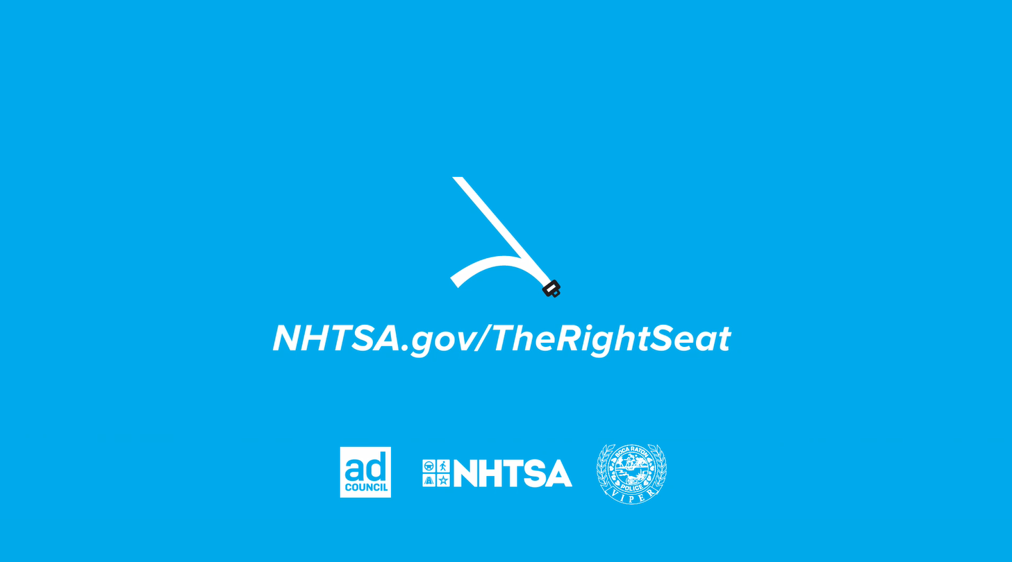
- Print: Print assets are available to be localized with one local logo.
  - Sample Print Asset:
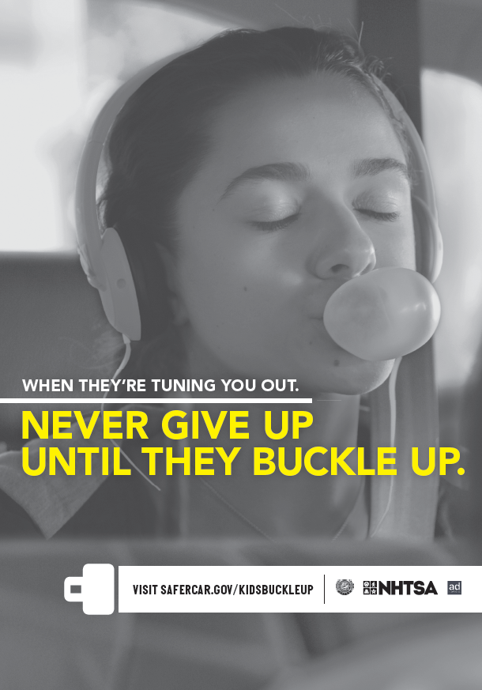

Child Car Safety Campaign

TV PSA LOCALIZATION ORDER FORM

Date: ____________

Primary Purpose of Use: Broadcast Social Media Internal Other (please specify) __________

Contact Name: __________________________________ Title: ___________________________

Email: __________________________________ Phone: __________________________

Organization Name: ________________________________________________________________

Organization Address: ______________________________________________________________

City: ______________________________ State: ____________________ Zip: _________

Designated Market Area to Reach with Localized PSA: _____________________________________

If not fulfilling to NHTSA.gov/TheRightSeat, enter one website address and one phone number (if applicable).
WEBSITE ADDRESS: _____________________________________
PHONE NUMBER: _______________________

Provide one local logo for the TV end frame. Email logo, along with this form to: Elizabeth.Nilsson@dot.gov. Logo must be submitted in an .EPS format, with an alpha channel (transparent layer).

Select the TV PSA you would like to localize.

The following PSAs are available for localization. Please only localize 1-2 videos per request:

English:

Select Files | Title | Length | Expiration Date | Paid | Donated
 | Carousel | :30 | Never | Yes | No
 | Carousel | :15 | Never | Yes | No
 | Bedtime | :30 | Never | Yes | No
 | Bedtime | :15 | Never | Yes | No
 | Minigolf | :30 | Never | Yes | No
 | Minigolf | :15 | Never | Yes | No
 | Baker | :30 | Never | Yes | No
 | Baker | :15 | Never | Yes | No
 | They’re Worth It | :60 | Never | Yes | No
 | Hoop | :15 | 10/13/2022 | No | Yes
 | Hoop | :30 | 10/13/2022 | No | Yes
 | Kitty | :15 | 10/13/2022 | No | Yes
 | Kitty | :30 | 10/13/2022 | No | Yes
 | 4am | :30 | 11/13/2022 | No | Yes
 | 4am | :15 | 11/13/2022 | No | Yes
 | 4am | :06 | 11/13/2022 | No | Yes
 | Play Place | :30 | 11/13/2022 | No | Yes
 | Play Place | :15 | 11/13/2022 | No | Yes
 | Play Place | :10 | 11/13/2022 | No | Yes
 | Math | :30 | 11/13/2022 | No | Yes
 | Math | :15 | 11/13/2022 | No | Yes
 | Soccer | :15 | 11/13/2022 | No | Yes
 | Soccer | :30 | 11/13/2022 | No | Yes
 | Soccer | :06 | 11/13/2022 | No | Yes
 | I Come Correct | :30 | 9/19/2023 | No | Yes
 | I Come Correct | :15 | 9/19/2023 | No | Yes
 | Hustle | :30 | 9/19/2023 | No | Yes
 | Hustle | :15 | 9/19/2023 | No | Yes

Spanish:

Select Files | Title | Length | Expiration Date | Paid | Donated
 | Carousel | :30 | Never | Yes | No
 | Carousel | :15 | Never | Yes | No
 | Bedtime | :30 | Never | Yes | No
 | Bedtime | :15 | Never | Yes | No
 | Minigolf | :30 | Never | Yes | No
 | Minigolf | :15 | Never | Yes | No
 | Baker | :30 | Never | Yes | No
 | Baker | :15 | Never | Yes | No
 | They’re Worth It | :60 | Never | Yes | No
 | Kitty | :15 | 10/13/2022 | No | Yes
 | Kitty | :30 | 10/13/2022 | No | Yes
 | 4am | :30 | 11/13/2022 | No | Yes
 | 4am | :15 | 11/13/2022 | No | Yes
 | 4am | :06 | 11/13/2022 | No | Yes
 | Soccer | :15 | 11/13/2022 | No | Yes
 | Soccer | :30 | 11/13/2022 | No | Yes
 | Soccer | :06 | 11/13/2022 | No | Yes
 | Equations | :30 | 11/13/2022 | No | Yes
 | Equations | :15 | 11/13/2022 | No | Yes
 | Play Place | :30 | 11/13/2022 | No | Yes
 | Play Place | :15 | 11/13/2022 | No | Yes
 | I Come Correct | :30 | 9/19/2023 | No | Yes
 | I Come Correct | :15 | 9/19/2023 | No | Yes
 | Hustle | :30 | 9/19/2023 | No | Yes
 | Hustle | :15 | 9/19/2023 | No | Yes

Enter file type.

MOV file of selected PSA

(For broadcast use)

MP4 file of selected PSA

(For digital use)

Child Car Safety Campaign

OUTDOOR PSA LOCALIZATION ORDER FORM

Date: ____________

Contact Name: __________________________________ Title: ___________________________

Email: __________________________________ Phone: __________________________

Organization Name: ________________________________________________________________

Organization Address: ______________________________________________________________

City: ______________________________ State: ____________________ Zip: _________

Designated Market Area to Reach with Localized PSA: _____________________________________

If not fulfilling to NHTSA.gov/TheRightSeat, provide either one website address OR one phone number (if applicable).
WEBSITE ADDRESS: ______________________________________
OR PHONE NUMBER: _______________________.

Select one local logo and email it to Elizabeth.Nilsson@dot.gov. Logo must be submitted in an .EPS format, with an alpha channel (transparent layer).

Select the Outdoor PSA you would like to localize.

The following PSAs are available for localization. Please only localize 1-4 OOH PSAs per request:

ENGLISH:

Select Files | Title | Size | Expiration Date | Paid | Donated
 | Messy Seat  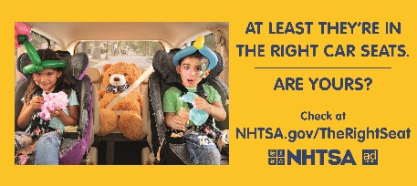 | 30-sheet | 9/21/2023 | Yes | Yes
 | Messy Seat  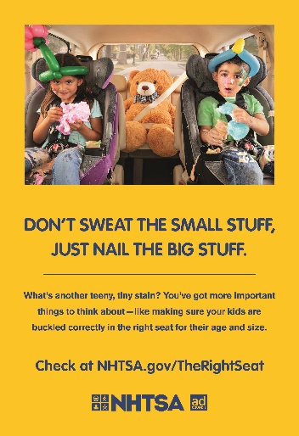 | Bus shelter | 9/19/2023 | Yes | Yes
 | Homemade Hairdos  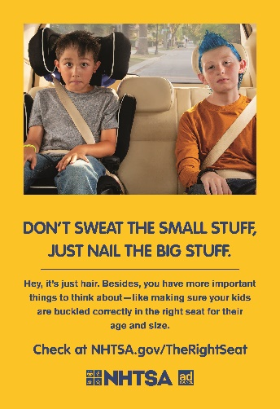 | Bus shelter | 9/23/2023 | Yes | Yes
 | Baby Car Seat  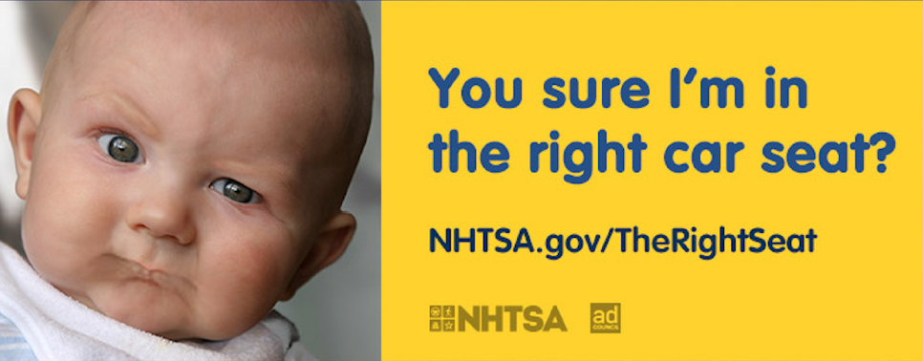 | 30-sheet | Never | Yes | Yes
 | Baby Car Seat  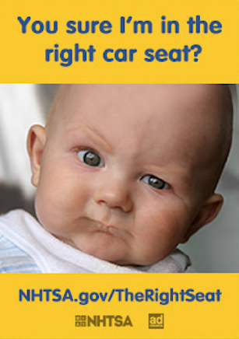 | Bus shelter | Never | Yes | Yes
 | Shapes and Sizes  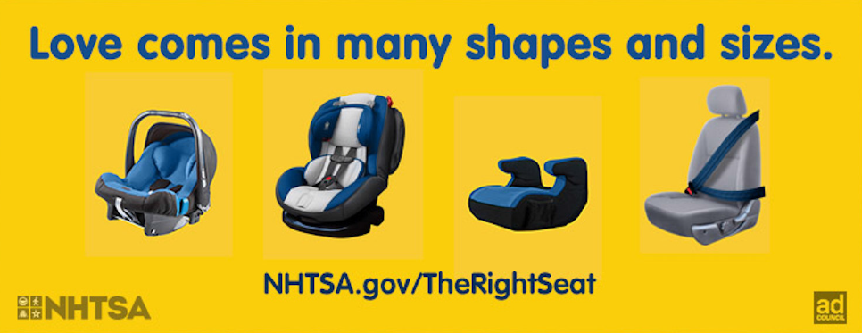 | 30-sheet | Never | Yes | Yes
 | Tween Boy  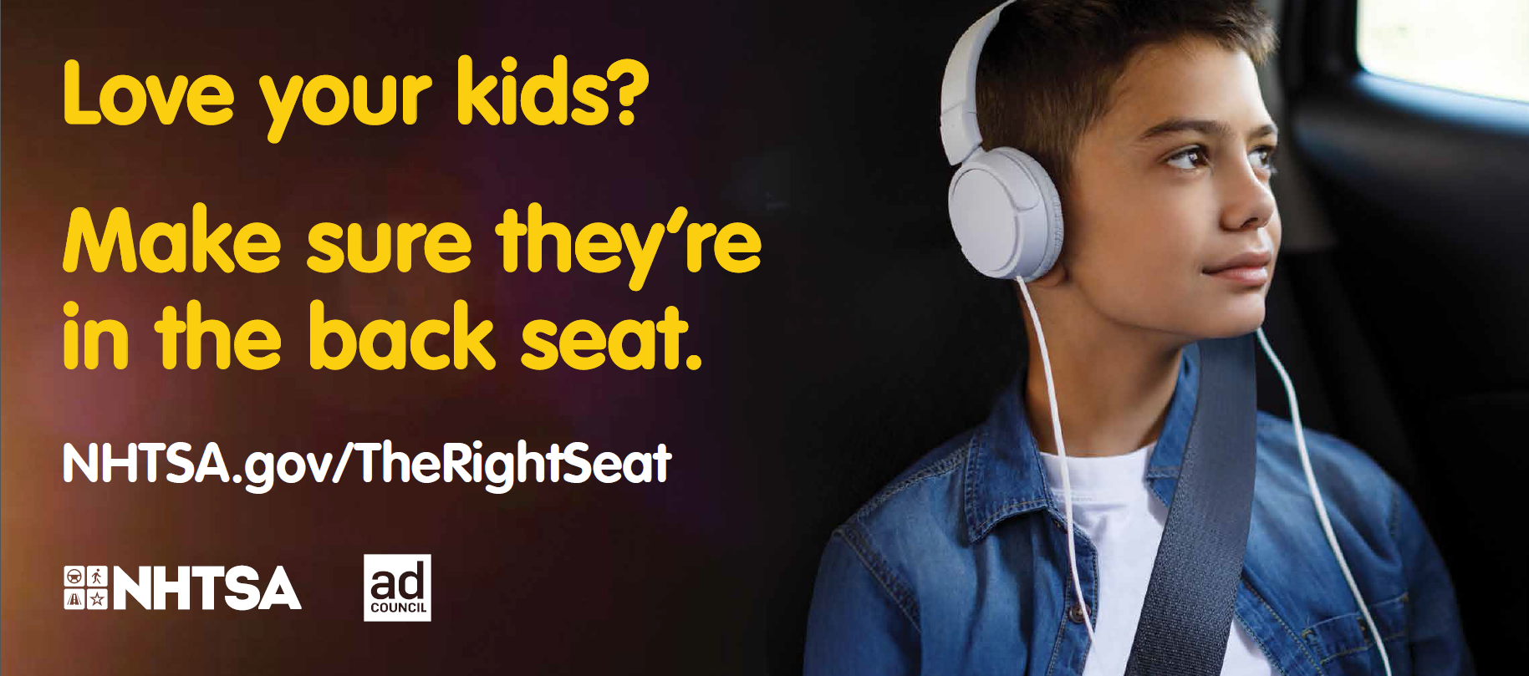 | 30-sheet | Never | Yes | Yes
 | Tween Buckle  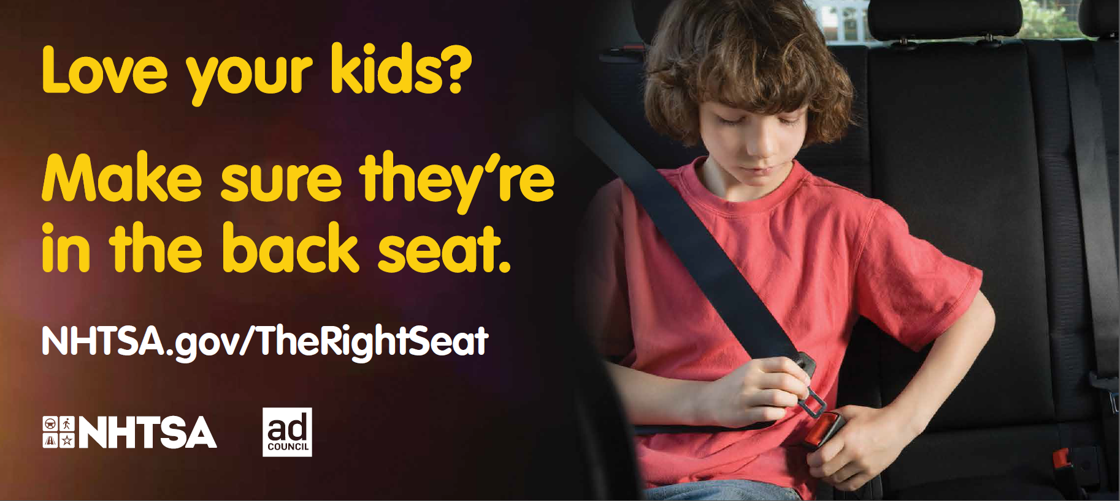 | 30-sheet | Never | Yes | Yes
 | Tween Girl  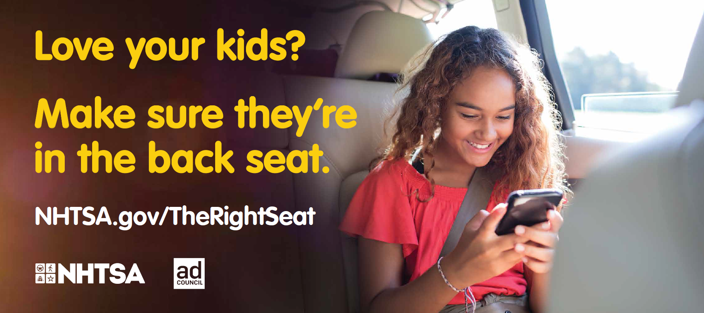 | 30-sheet | Never | Yes | Yes
 | Right Car Seat  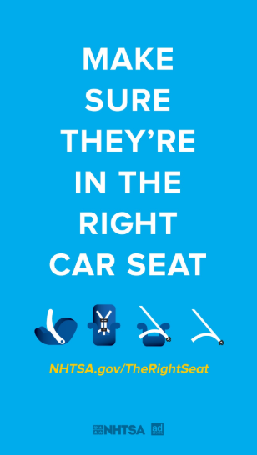 | Bus shelter | 1/12/24 | Yes | Yes
 | Right Car Seat  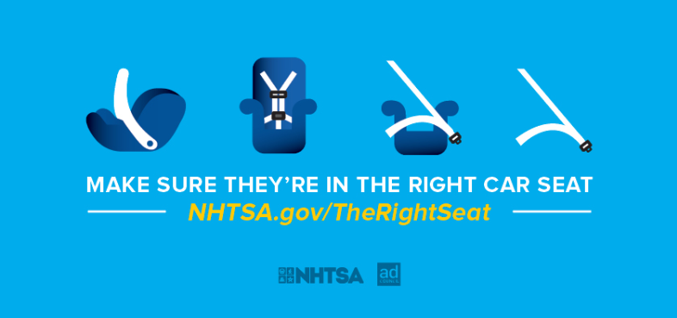 | 30-sheet | 1/12/24 | Yes | Yes
 | Turning Out Tablet  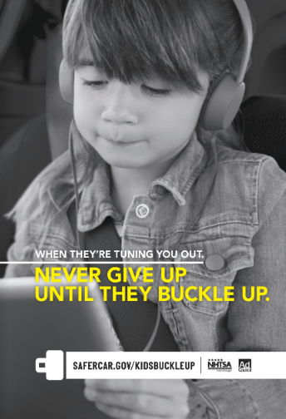 | Bus shelter | Never | Yes | Yes
 | Games Begin  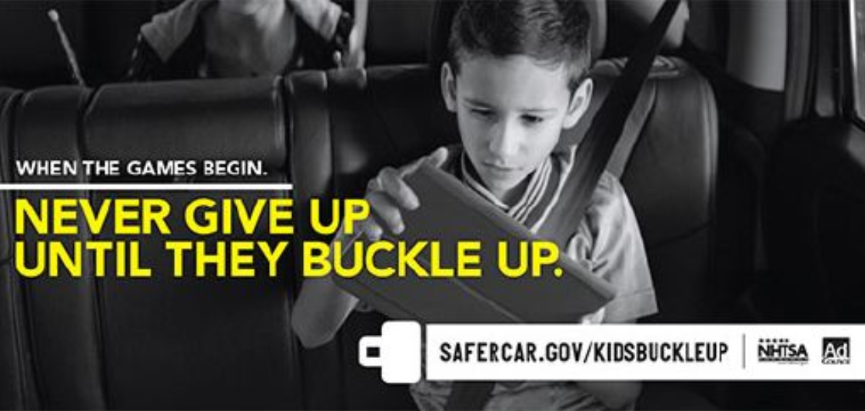 | 30-sheet | Never | No | Yes
 | Games Begin  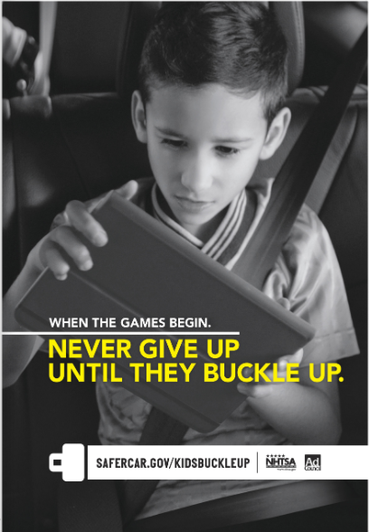 | Bus shelter | Never | No | Yes
 | Chaos  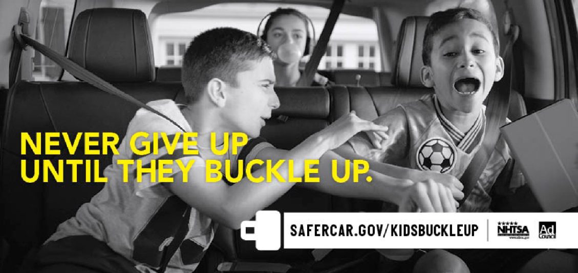 | 30-sheet | Never | No | Yes

Spanish

Select Files | Title | Size | Expiration Date | Paid | Donated
 | Messy Seat | 30-sheet | 9/22/2023 | Yes | Yes
 | Messy Seat | Bus shelter | 9/20/2023 | Yes | Yes
 | Homemade Hairdos | Bus shelter | 9/24/2023 | Yes | Yes
 | Baby Car Seat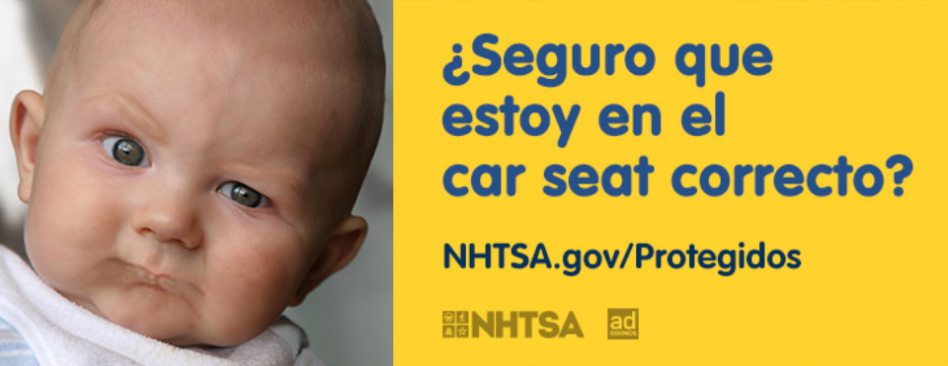 | 30-sheet | Never | Yes | Yes
 | Baby Car Seat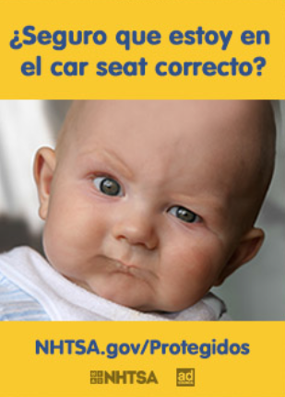 | Bus Shelter | Never | Yes | Yes
 | Shapes and Sizes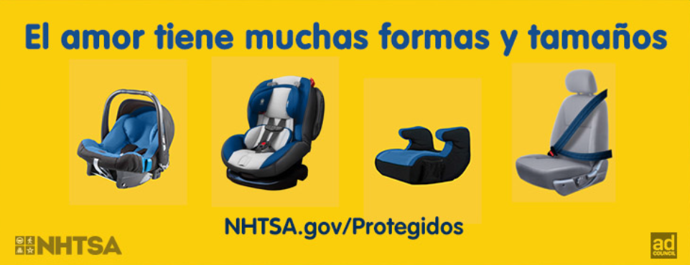 | 30-sheet | Never | Yes | Yes
 | Tween Boy  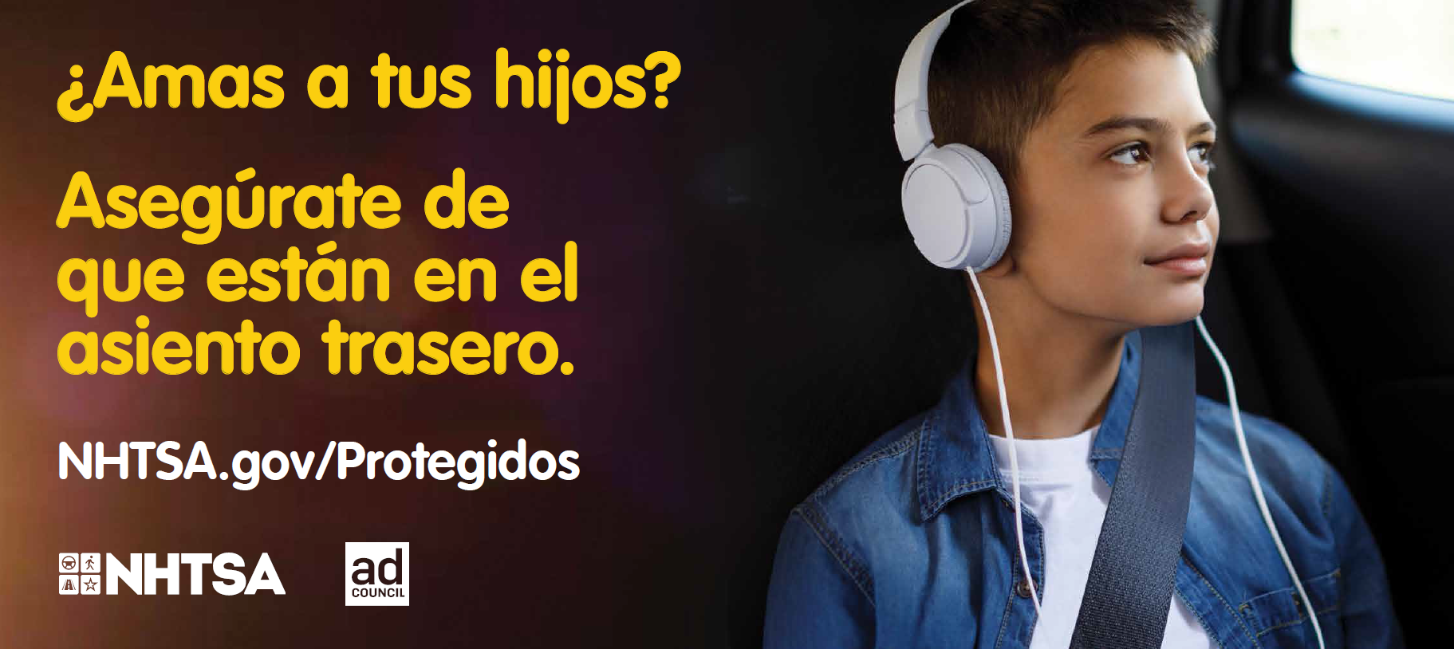 | 30-sheet | Never | Yes | Yes
 | Tween Buckle  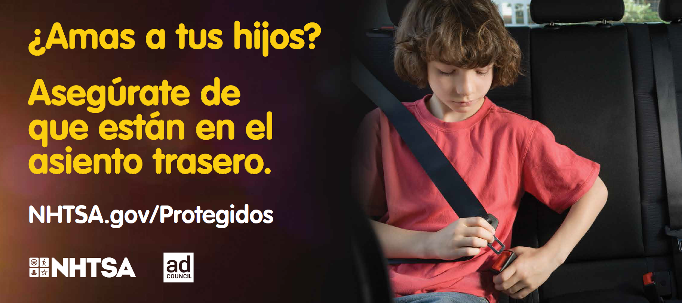 | 30-sheet | Never | Yes | Yes
 | Tween Girl  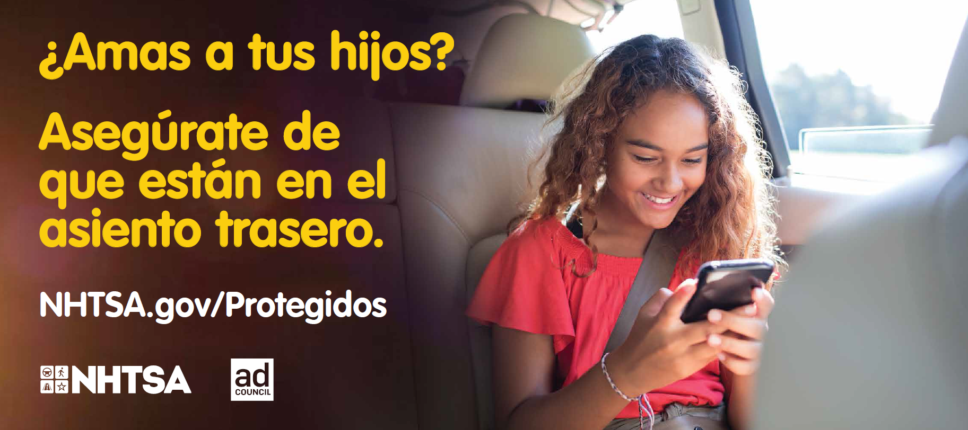 | 30-sheet | Never | Yes | Yes
 | Office  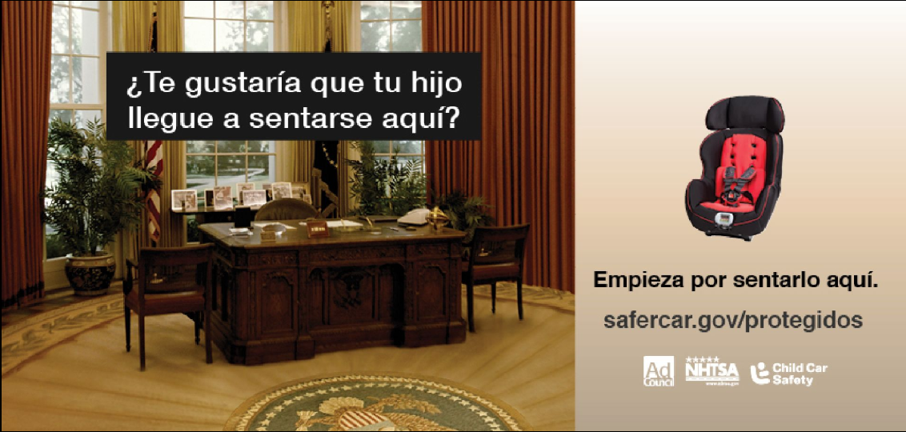 | 30-sheet | Never | Yes | Yes
 | Locker  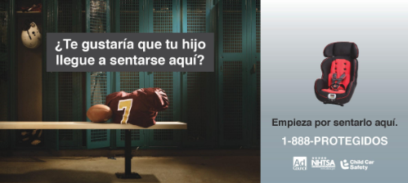 | 30-sheet | Never | Yes | Yes
 | Chaos  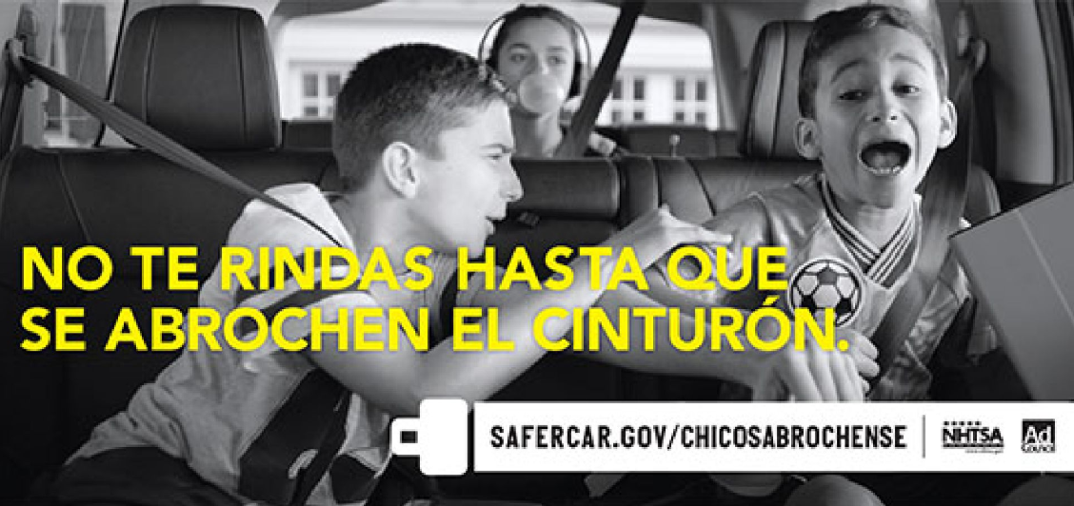 | 30-sheet | Never | No | Yes
 | Games Begin  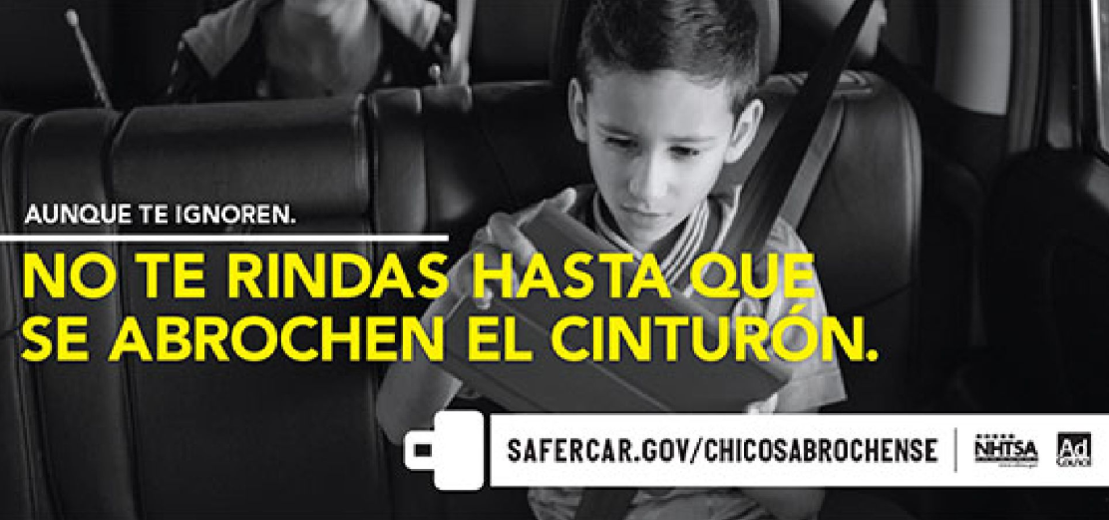 | 30-sheet | Never | No | Yes
 | Games Begin  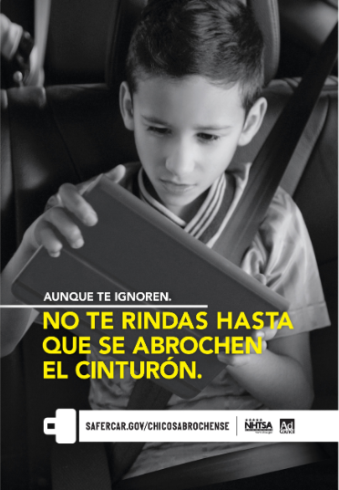 | Bus Shelter | Never | No | Yes

Include the name and address of the outdoor company that should receive the Outdoor PSA:

Name: ________________________________________________________________

Address: ______________________________________________________________

City: ______________________________ State: ____________________ Zip: _________

Child Car Safety Campaign

PRINT PSA LOCALIZATION ORDER FORM

Date: ____________

Contact Name: __________________________________ Title: ___________________________

Email: __________________________________ Phone: __________________________

Organization Name: ________________________________________________________________

Organization Address: ______________________________________________________________

City: ______________________________ State: ____________________ Zip: _________

Designated Market Area to Reach with Localized PSA: _____________________________________

If not fulfilling to NHTSA.gov/TheRightSeat, provide one website address and one phone number (if applicable).

WEBSITE ADDRESS: ______________________________________
and PHONE NUMBER: _______________________.

Select one local logo and email it to Elizabeth.Nilsson@dot.gov. Logo must be submitted in an .EPS format, with an alpha channel (transparent layer).

Select the Print PSA you would like to localize.

The following PSAs are available for localization. Please only localize 1-4 print PSAs per request:

ENGLISH

Select Files | Title | Size | Expiration Date | Paid | Donated
 | Right Car Seat | Magazine:  7x10  7 7/8 x 10 ½  4 5/8 x 4 7/8  4 5/8 x 10  7 x 4 7/8  Newspaper:  11 ½ x 21  5 11/16 x 10 ½  11 ½ x 10 1/2  9.889 x 3  7 x 4 7/8 | Never | Yes | Yes
 | Messy Seat  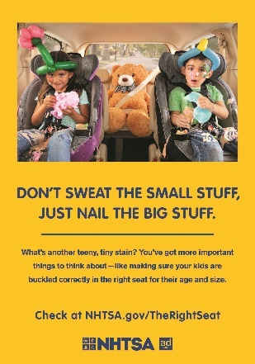 | 7 x 10, 4C  11 ½ x 21, 4C  11 ½ x 21, BW | 9/19/2023 | Yes | Yes
 | Homemade Hairdos  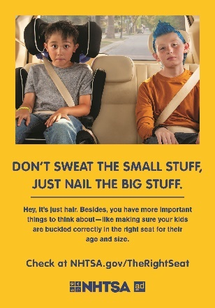 | 7 x 10, 4C  11 ½ x 21, 4C  11 ½ x 21, BW | 9/19/2023 | Yes | Yes
 | Hot Cross Buns  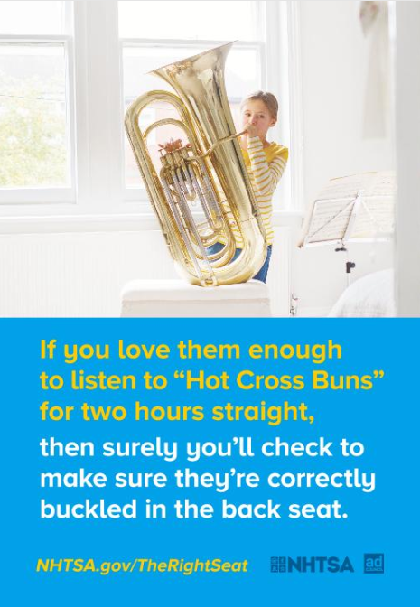 | 7x10 4C,  11.5x21 4C,  11.5 x 21 BW | Never | Yes | Yes
 | 4am  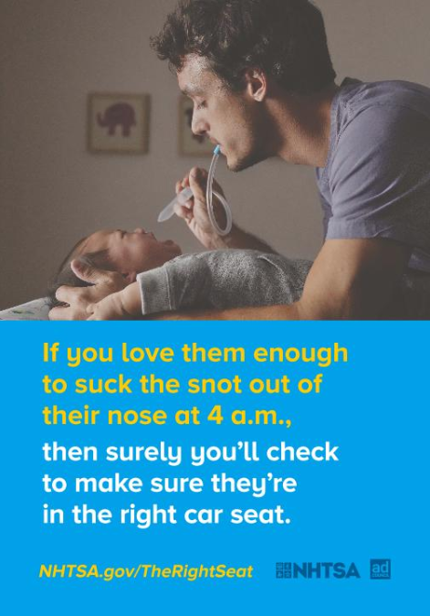 | 7x10 4C,  11.5x21 4C,  11.5 x 21 BW | 11/13/2022 | Yes | Yes
 | Movie  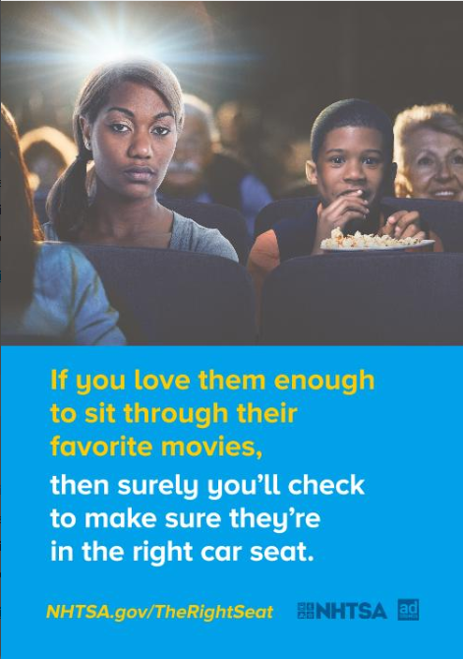 | 7x10 4C,  11.5x21 4C,  11.5 x 21 BW | 9/28/2028 | Yes | Yes
 | Popsicle  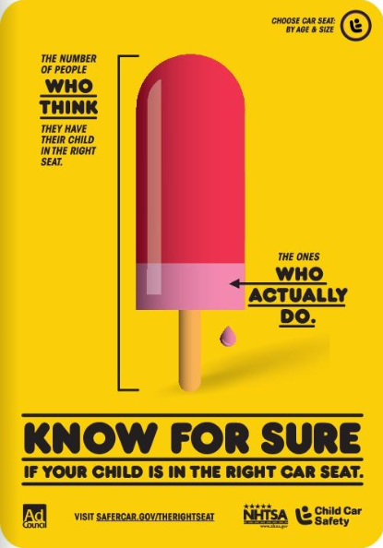 | 7x10 4C,  11.5x21 4C,  11.5 x 21 BW | Never | Yes | Yes
 | Baby bottle  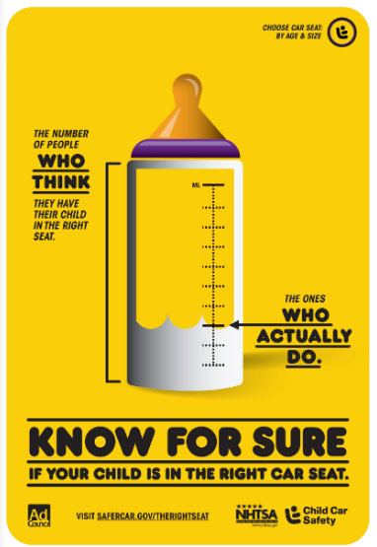 | 7x10 4C,  11.5x21 4C,  11.5 x 21 BW | Never | Yes | Yes
 | Sneaker  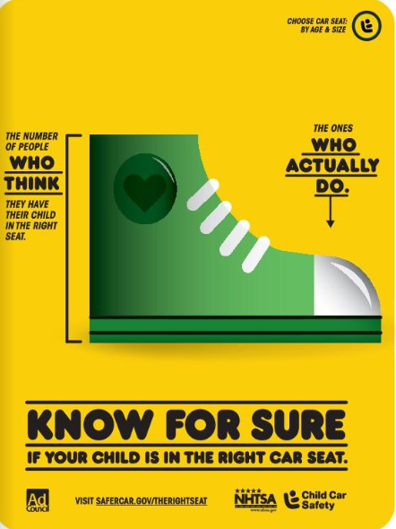 | 7x10 4C,  11.5x21 4C,  11.5 x 21 BW | Never | Yes | Yes
 | Chaos  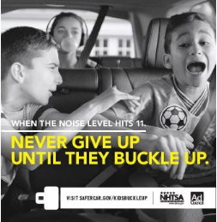 | 7x10 4C,  11.5x21 4C,  11.5 x 21 BW | Never | No | Yes
 | Around the Corner  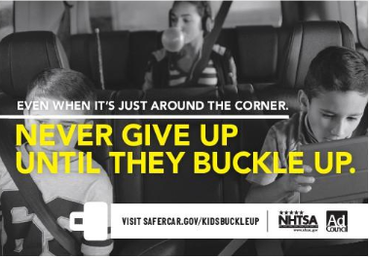 | 7x10 4C,  11.5x21 4C,  11.5 x 21 BW | Never | No | Yes
 | Games Begin  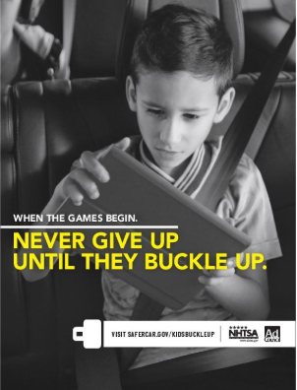 | 7x10 4C,  11.5x21 4C,  11.5 x 21 BW | Never | No | Yes
 | Tuning Out Gum  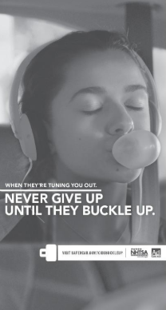 | 7x10 4C,  11.5x21 4C,  11.5 x 21 BW | Never | Yes | Yes

Spanish

Select Files | Title | Size | Expiration Date | Paid | Donated
 | Messy Seat  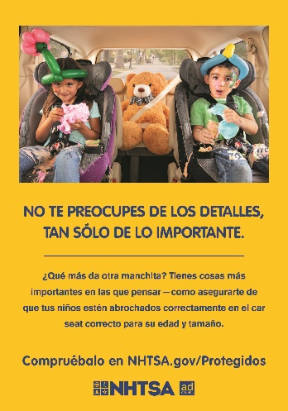 | 7 x 10, 4C  11 ½ x 21, 4C  11 ½ x 21, BW | 9/19/2023 | Yes | Yes
 | Homemade Hairdos  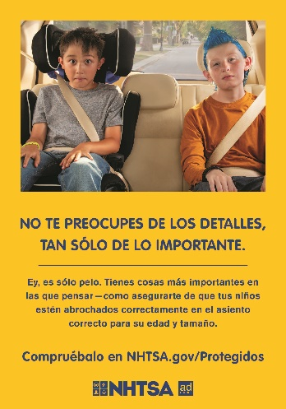 | 7 x 10, 4C  11 ½ x 21, 4C  11 ½ x 21, BW | 9/19/2023 | Yes | Yes
 | Locker  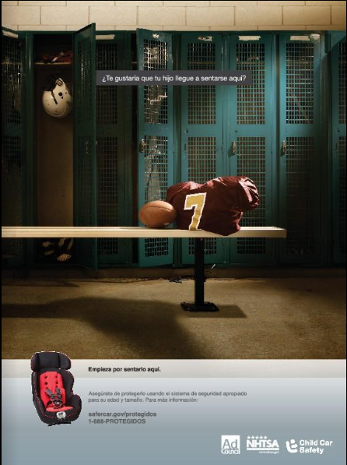 | 7x10 4C,  11.5x21 4C,  11.5 x 21 BW | Never | Yes | Yes
 | Chaos  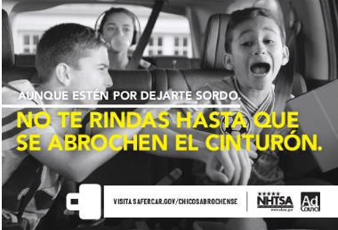 | 7x10 4C, 11.5x21 4C,  11.5 x 21 BW | Never | No | Yes
 | Around the Corner  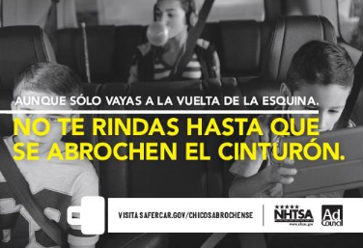 | 7x10 4C,  11.5x21 4C,  11.5 x 21 BW | Never | No | Yes
 | Tuning out Gum  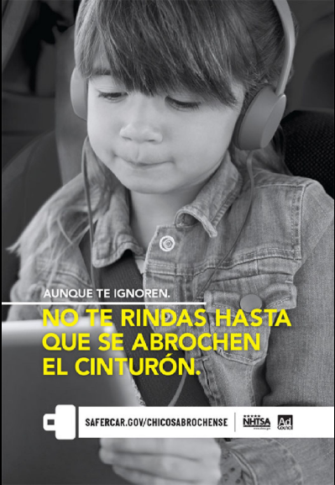 | 7x10 4C,  11.5x21 4C,  11.5 x 21 BW | Never | Yes | Yes

If you selected Other, please provide / attach the size specifications required for this placement: ____________________________________________________________________________________________________________________________________________________________________

